ELECENG 3TP3
Lab #1 Report
Instructor: Dr. Kiruba
Jasmine Dosanjh – dosanj5 – 400531879
Warisha Noushad – noushadw – 400519903
October 21, 2025

Question 1
1. (a)
n = -10:10;
% Create an instance of the SimpleFunctions object.
f = SimpleFunctions();
% Evaluate an = term n, then plot x[n]
a1 = f.unitstep(n);
a2 = f.unitstep(n-1);
a3 = f.unitstep(n-4);
xn = a1 - 2*a2 + a3;
stem(n, xn, 'LineWidth', 3);

% For Lab Report
text(-12, 1.1, 'Jasmine Dosanjh 400531879', 'FontSize', 10, 'Color', 'b');
text(1, 1.1, 'Warisha Noushad 400519903', 'FontSize', 10, 'Color', 'r');
exportgraphics(gcf, 'Q1a_Plot.jpg');

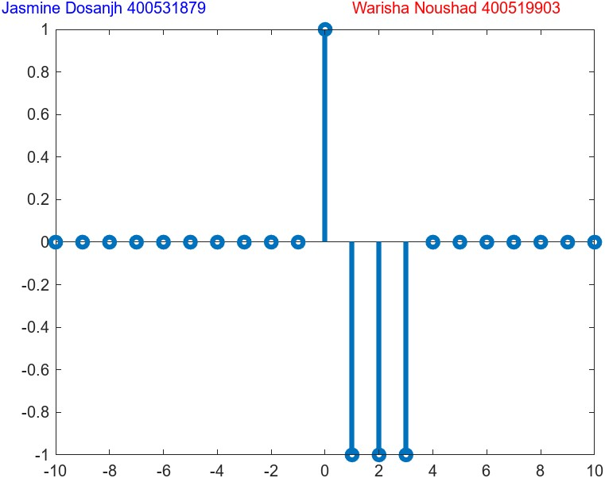

1. (b)
n = -10:10;
% Create an instance of the SimpleFunctions object.
f = SimpleFunctions();
% Evaluate an = term n, then plot x[n]
a1 = f.unitstep(n+2);
a2 = f.unitstep(n);
a3 = f.unitstep(n-4);
xn = (n+2).*a1 - 2*a2 - n.*a3;
stem(n, xn, 'LineWidth', 3);

% For Lab Report
text(-12, 1.1, 'Jasmine Dosanjh 400531879', 'FontSize', 10, 'Color', 'b');
text(1, 1.1, 'Warisha Noushad 400519903', 'FontSize', 10, 'Color', 'r');
exportgraphics(gcf, 'Q1b_Plot.jpg');

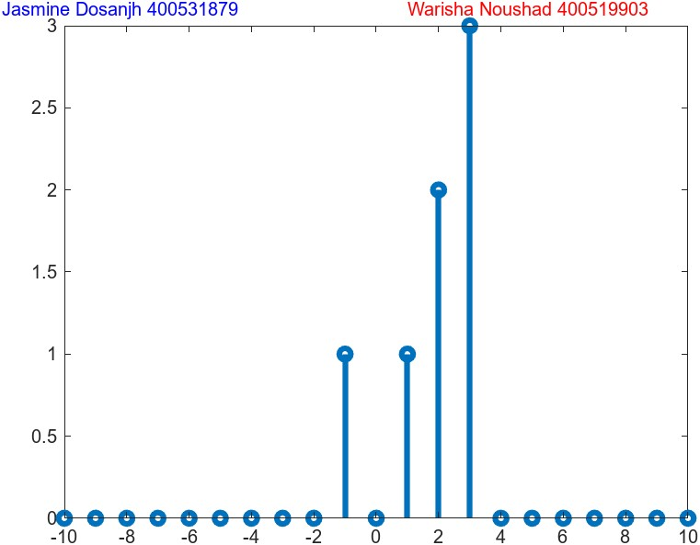
1. (c)
n = -10:10;
% Create an instance of the SimpleFunctions object.
f = SimpleFunctions();
% Evaluate an = term n, then plot x[n]
a1 = f.delta(n+1);
a2 = f.delta(n);
a3 = f.unitstep(n+1);
a4 = f.unitstep(n-2);
xn = a1 - a2 + a3 - a4;
stem(n, xn, 'LineWidth', 3);

% For Lab Report
text(-12, 3.1, 'Jasmine Dosanjh 400531879', 'FontSize', 10, 'Color', 'b');
text(1, 3.1, 'Warisha Noushad 400519903', 'FontSize', 10, 'Color', 'r');
exportgraphics(gcf, 'Q1c_Plot.jpg');

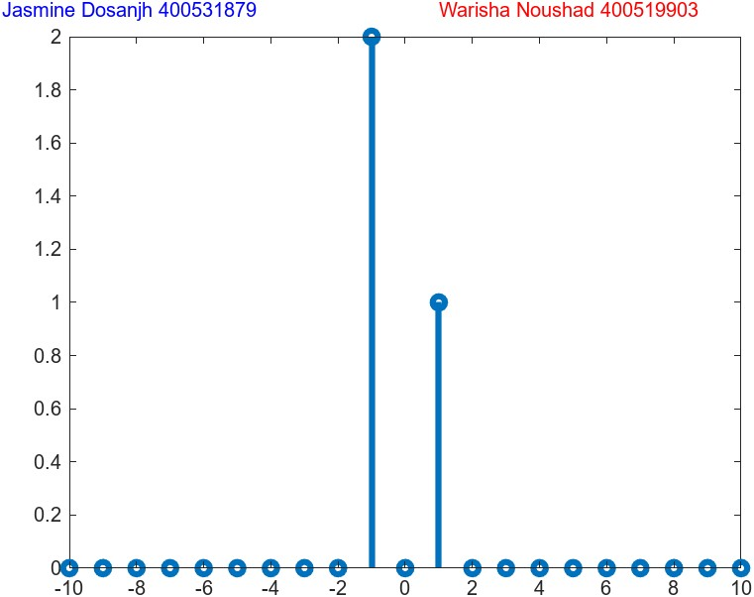
1. (d)
n = -10:10;
% Create an instance of the SimpleFunctions object.
f = SimpleFunctions();
% Evaluate an = term n, then plot x[n]
a1 = f.unitstep(n+1);
a2 = f.unitstep(n);
xn = exp(0.8.*n).*a1 + a2;
stem(n, xn, 'LineWidth', 3);

% For Lab Report
text(-12, 2800, 'Jasmine Dosanjh 400531879', 'FontSize', 10, 'Color', 'b');
text(-1, 2800, 'Warisha Noushad 400519903', 'FontSize', 10, 'Color', 'r');
exportgraphics(gcf, 'Q1d_Plot.jpg');

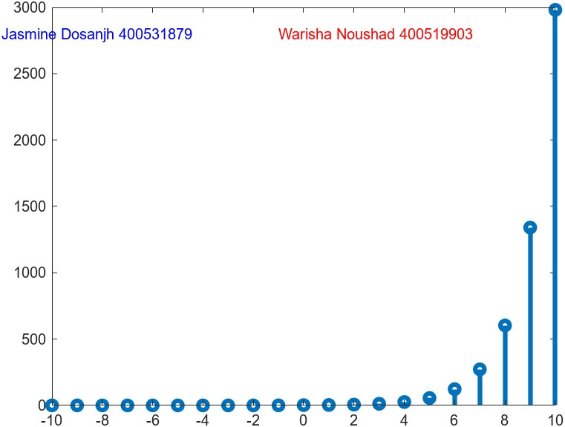

Question 2
2. (a)
% Read table array file
opts = detectImportOptions('course_grades_2024.xlsx');
opts = setvartype(opts, {'ID_Number', 'Name'}, 'string'); % import id and name columns as strings
table = readtable('course_grades_2024.xlsx', opts) % table array

% Extract Name and Lab Mark columns
gradesTable = table(:,[1 3 4 5 6])

% Sort table with highest total lab mark at top
sortedGrades = sortrows(gradesTable,["Lab_1" "Lab_2" "Lab_3" "Lab_4"],"descend")

% Extract student with highest total lab mark from top
topStudent = sortedGrades(2,:)

% Output Highest total lab mark and Name
Name = topStudent.Name
totalMark = topStudent.Lab_1 + topStudent.Lab_2 + topStudent.Lab_3 + topStudent.Lab_4

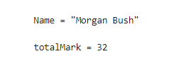

2. (b)
% Read table array file
opts = detectImportOptions('course_grades_2024.xlsx');
opts = setvartype(opts, {'ID_Number', 'Name'}, 'string'); % import id and name columns as strings
table = readtable('course_grades_2024.xlsx', opts) % table array

% Extract Name and Exam Mark columns
gradesTable = table(:,[1 8 9 10 11])

% Sort table with highest total exam mark at top
sortedGrades = sortrows(gradesTable,["Exam_1" "Exam_2" "Exam_3" "Exam_4"],"descend")

% Extract student with highest total exam mark from top
topStudent = sortedGrades(2,:)

% Output Highest total lab exam and Name
Name = topStudent.Name
totalMark = topStudent.Exam_1 + topStudent.Exam_2 + topStudent.Exam_3 + topStudent.Exam_4

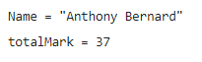
2. (c)
% Read table array file
opts = detectImportOptions('course_grades_2024.xlsx');
opts = setvartype(opts, {'ID_Number', 'Name'}, 'string'); % import id and name columns as strings
table = readtable('course_grades_2024.xlsx', opts) % table array

% Extract Name and Mark columns
gradesTable = table(:,[1 3:11])

% Sort table with highest total mark at top
sortedGrades = sortrows(gradesTable,["Exam_1" "Exam_2" "Exam_3" "Exam_4" "Lab_1" "Lab_2" "Lab_3" "Lab_4" "Midterm"],"descend")

% Extract student with highest total exam mark from top
topStudent = sortedGrades(2,:)

% Output Highest total lab exam and Name
Name = topStudent.Name
totalMark = topStudent.Exam_1 + topStudent.Exam_2 + topStudent.Exam_3 + topStudent.Exam_4 + topStudent.Lab_1 + topStudent.Lab_2 + topStudent.Lab_3 + topStudent.Lab_4 + topStudent.Midterm

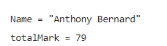

2. (d)
% Read table array file
opts = detectImportOptions('course_grades_2024.xlsx');
opts = setvartype(opts, {'ID_Number', 'Name'}, 'string'); % import id and name columns as strings
table = readtable('course_grades_2024.xlsx', opts) % table array

% Create new row entries
newRow1 = {"Jasmine Dosanjh", "400531879", 100, 78, 52, 44, 100, 78, 52, 44, 52}
newRow2 = {"Warisha Noushad", "400519903", 88, 90, 47, 21, 99, 78, 82, 76, 92}

% Add new row entries in the table
table = [table ; newRow1 ; newRow2]

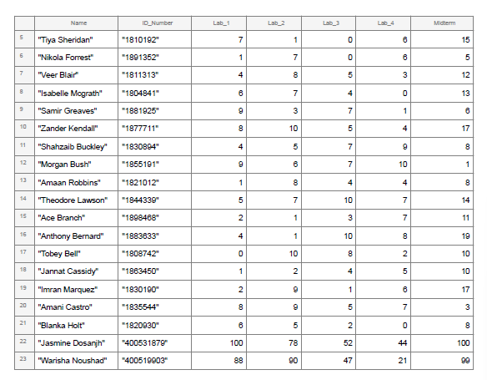
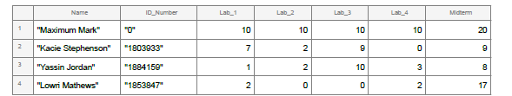

Part 3 Questions

Question 3
% Read image into a matrix
img = imread('ee3tp3picture2024.jpg');

% Extract out each colour component
red = img(:,:,1);
green = img(:,:,2);
blue = img(:,:,3);

% Rescale red and green by different factors
redScaled = 5.5*red;
greenScaled = 5.5*green;

% Recombine the three components into a new 3D image
reconstructed_image = cat(3, redScaled, greenScaled, blue);

% Display reconstructed image
imshow(reconstructed_image)

% Save final result
imwrite(reconstructed_image, 'my_fixed_image.jpg')

